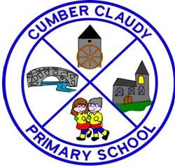

INFORMATION

Cumber Claudy Primary School Primary
20 Cregg Road Controlled
Claudy Boys and Girls
Londonderry
BT47 4HX Age Range: 4 - 11
Tel: 028 71 337080
Fax: 028 71 338913 Email: info@cumberclaudy.claudy.ni.sch.uk
Website: cumberclaudyps.co.uk

Chairman of Governors: Mr S Brown
Principal: Mrs M Smyth
Number on roll 1 September 2013: 126
Admissions Number: 28 Enrolment Number: 199

Board of Governors

Representing Transferors

Rev’d D Slater
Mr T Rosborough
Mr S Brown

Representing Board

Mrs M Hamilton
Mrs J Lindsay

Representing Parents

Mrs K Breslin
Mrs L McSparron

Representing Teachers

Mrs L D Hume

The Principal/Secretary (Non-voting)

Mrs M Smyth

1

Teaching Staff

Primary 1 Mrs M Smallwood

Primary 2 Miss E Funston

Primary 3/4 Mrs D Hume

Primary 4/5 Mrs J Todd

Primary 6 Mr M Carlisle

Primary 7 Miss L McCracken

Ancillary Staff

School Secretary Mrs N Eakin
P1 Classroom Assistant/Special Needs Assistant Mrs K Brown
Special Needs Classroom Assistants Miss I Riddles
Miss D Starrett
General Classroom Assistant Miss H Hamilton
Caretaker Mrs M Coll
Assistant Cleaner Mrs A Newland

Meals Staff

Cook in Charge Ms Joanne O’Neill
Kitchen Assistants Mrs C McClelland
Mrs M Haslett

Senior Meals Supervisor Mrs E Eakin



2

GENERAL INFORMATION

Cumber Claudy Primary School is a controlled school owned and maintained by the Western Education & Library Board. It is set in its own lovely grounds in a delightful rural area, on the outskirts of Claudy village, just off the main Londonderry to Claudy road.

The school, which is a modern, well laid out and attractive building, was opened in September 1994, to replace three smaller schools, Cumber Upper, Killaloo-Cumber and Straidarran. The school has a current enrolment of 126 pupils with a teaching complement of 6 plus the Principal.

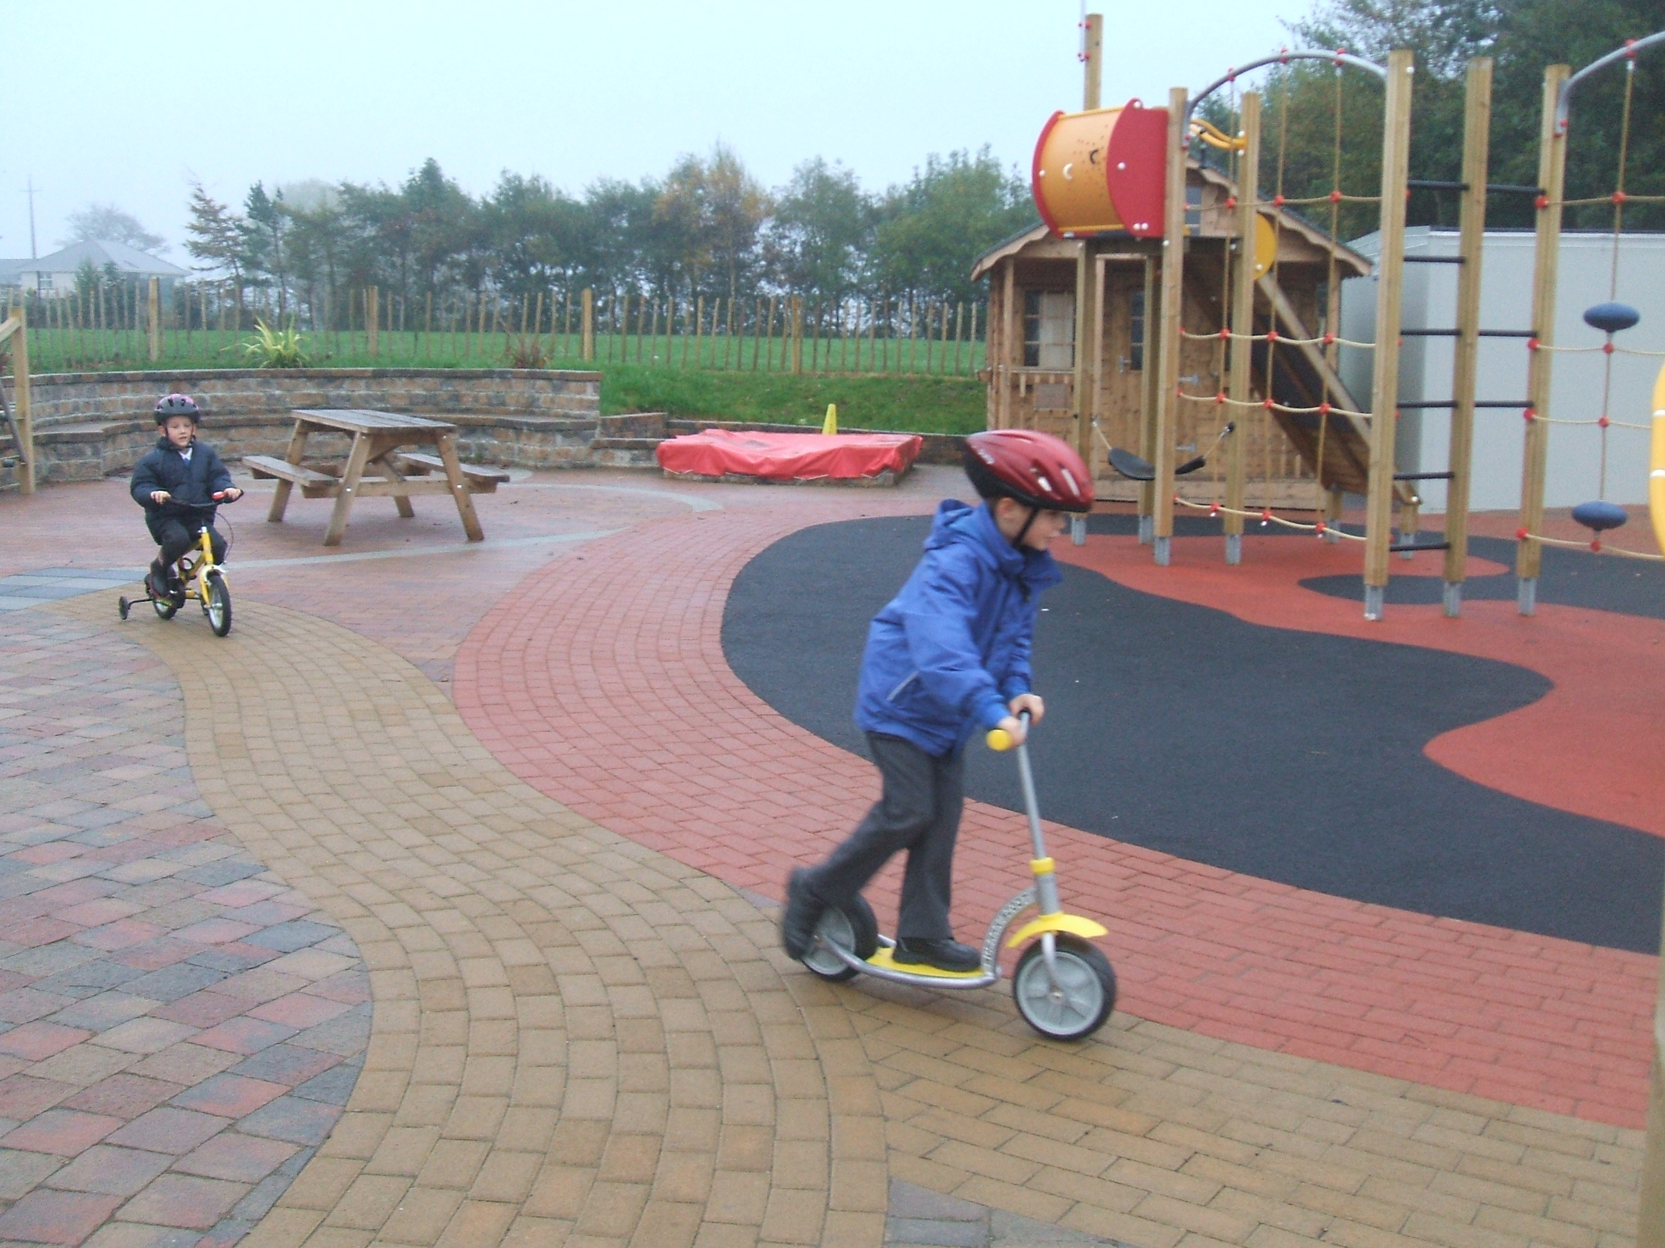
Cumber Claudy Primary School admits boys and girls aged from 4 to 11 years. The accommodation includes 6 well equipped classrooms all with interactive whiteboards, the 2 resource areas, an assembly hall, a staffroom, offices and a school meals kitchen. We have a computer suite situated in the senior resource area of the school, complete with interactive whiteboard. The junior resource area is a well-equipped structured play area for our infants and junior pupils. The school grounds have excellent play facilities for all pupils.

The school seeks to promote a friendly, caring atmosphere, and parents are always welcome to visit the school.

School Hours


The school day begins at 9.00 am and children should be in their classrooms by this time. Children will be admitted to the school from 8.40 am onwards. Children who arrive at school after 8.30 am and before 8.40 am must have a prior agreement with the Principal, and no responsibility can be taken by the school for any children arriving on the premises before 8.30 am. Parents should seek access through the main front door via the intercom system.

The mid-morning break is from 10.30 am - 10.45 am for all pupils.. The lunch break is from 12.15 pm - 1.00 pm for KS1 pupils and 12.25pm – 1.10pm for KS2 pupils. We operate a cafeteria system for dinners with Foundation Stage and Key Stage 1 pupils being served first.

The P1 and P2 classes finish their school day at 2.00 pm, and the P3/P7 classes finish their school day at 3.00 pm, with the exception of Wednesday and Friday when P3 finish at 2.00 pm.
Attendance


All children should attend school for the 190 days which law requires, unless they are ill. If children have to miss school for illness or any other reason, then parents should send into school, a note explaining the absence for our records. Pink Absence Report Forms are issued from the school office for completion on each absence.

3

ADMISSION ARRANGEMENTS

The current policy is, at the beginning of the school year, to admit into the P1 class, those children who have reached compulsory school age, i.e. those children whose 4th birthday falls on or before 1st July of the current year.
Parents considering sending their children to this school are invited to make a prior visit, to see the school in action and to talk to the principal and teachers. A Primary 1 Induction programme will be arranged in May/June for parents and children.

The admission arrangements as set out in the WELB booklet on Primary Education will be used. Application forms are available from the school or Board offices.

ADMISSIONS CRITERIA

The Board of Governors will apply the following criteria, in the event of there being more applicants than places available, in the order set down.

- Children of compulsory school age who already have an established connection with the school, or with any of the three schools

that it replaced (i.e. those who have had, or
presently have brothers or sisters attending the school, or
those whose mother or father had attended one of the
three former schools).

2. Children of compulsory school age who live in the local
area and also those who live in the area served by our
existing school bus.

3. Other children of compulsory school age.

Priority will be given, in the application of each criterion, to pupils regarded by the Board of Governors, on the basis of supporting evidence from parents and/or statutory agencies, as having special circumstances, (i.e. medical, social, security).

Preference will be given to children with exceptional circumstances (medical, social or other problems) that necessitate admission to Cumber Claudy Primary School rather than any other primary school. The circumstances should be personal to the child and must be supported by independent and appropriate documentation, providing evidence of the circumstances being described as being exceptional.

If there are more applicants satisfying the last one of the above criteria that can be applied, than there are places remaining, then selection will take place on the basis of the closeness of the home to the school, as measured by the shortest walking distance.

4
GENERAL AIMS OF THE SCHOOL

- To create a happy stimulating and secure environment to promote learning.

- To offer a curriculum which is broad and balanced, and incorporates the requirements of the NI Curriculum, to ensure that the children have access to an education which will develop them as caring, independent, competent, confident individuals, who could take their place in society.

- To promote the intellectual, physical, social cultural, emotional and moral development of each child to his/her full potential.

- To develop respect for religious and moral values, and tolerance of other races, religions and ways of life.

- To liaise and consult with the Board of Governors on all matters pertaining to the effective management of the school.

- To keep parents informed about the progress of their children, involve them in the life of the school, and to encourage their participation, co-operation and support in the education and development of their children, as partners with the Board of Governors and the staff.

CURRICULUM

The curriculum of the school is designed to give a broad and balanced education to all children and to present all children with experiences suitable to their current stages of development.

The curriculum is in a constant state of development and during 2013/2014 the staff will continue to implement the demands of the NI Curriculum. The school provides worthwhile experiences in all the areas of study of the NI Curriculum which are:-

The Arts
Language +Literacy
Mathematics + Numeracy
Personal Development + Mutual Understanding
Physical Education
The World around Us
Religion Education

CCPS will be strive to present children with lively and exciting experiences, which will enable them to fulfil the NI Curriculum requirements with enthusiasm and to attain the targets that are within their abilities.

The School Development Plan is underpinned by the most recent school improvement document “Every School a Good School” which promotes the ongoing development of Literacy, Numeracy and ICT. We aim to keep abreast of all educational initiatives and view self-evaluation and ongoing school improvement as areas of high priority. Staff are involved in frequent and relevant in-service training programmes to best support the needs of all our pupils and impact positively on learning and teaching within the school.
5
Staff have a strong sense of pride and commitment to the school, and are convinced that the school is making a difference and has good standing in the local community.

With regard to the findings of the recent inspection it was noted that parents expressed their pleasure in the quality of education and care provided by the staff and the approachability of all staff in school. Children themselves spoke happily and enthusiastically about their experiences at school, and the support and encouragement they received from the staff.

RELIGIOUS EDUCATION

The teaching of RE, in each age group, is based on the core syllabus for Northern Ireland and is of a non-denominational character. Parents have the right to withdraw their children from RE lessons and should inform the principal, in writing, of their wishes if they want to exercise this right.
The school takes great care to try to ensure that any children in this position are not made to feel excluded from the general life of the school.

EDUCATION FOR MUTUAL UNDERSTANDING (EMU)

Our school has established cross-community links with St Mary’s Primary School, Altinure and organises a successful and profitable educational program, for P5 through to P7.

We also work closely with our neighbouring school, St Colmcilles, on curricular or promotional ventures which have been mutually beneficial.

Links with St Patrick’s & St Brigid’s College have been greatly strengthened owing to their specialist status for Business and Enterprise. KS2 pupils and teachers have benefited greatly from carefully planned projects using the college’s expertise and resources.

CLASS ORGANISATION AND ASSESSMENT

Pupils are placed in mixed ability classes according to age. Each teacher uses a variety of teaching methods to meet the needs of every child in the class. Children are taught individually or in groups according to their ability and achievement level. Observation coupled with formal and informal assessment identifies the strengths and weaknesses of each pupil. Care is taken at all times to match the curricular provision for all children to their particular stage of development and to take account of any particular difficulties or special talents which they show. Where a child’s progress gives cause for concern the specialist service of the Board’s Special Education Section will be used. Each child’s progress is continuously monitored and shared with the parents at parent/teacher meetings scheduled for the Autumn and Spring terms. A comprehensive written report is issued to parents at the end of each school year.

6

End of Key Stage 1 & 2 Results – 2012/2013

 |  |  | Cumber Claudy Primary School | Northern Ireland
Key Stage 1 | English | Level 2 and above
 |  | Level 3
 | Maths | Level 2 and above
 |  | Level 3
Key Stage 2 | English | Level 4 and above
 |  | Level 5
 | Maths | Level 4 and above
 |  | Level 5

HOME/SCHOOL CONTACT


Parental contacts with the school are actively encouraged by the teaching staff. The parent’s support is essential in working with the school for the child’s benefit. This school attempts to foster parental relationships in various ways such as invitations to concerts, educational outings, curriculum activities of a practical nature and other events, as well as informal contacts at the beginning and end of the school day.

Parents will be kept informed about their child’s progress termly, Parent/teacher interviews will be held during the Autumn and the Spring terms and at the end of the summer term a formal written report will be issued for each pupil. Pupils from P2 upwards are supported in setting individual targets throughout the year in both Literacy and Numeracy. These are communicated to parents, progress is monitored and used to inform future planning and reporting. Parents may contact the Principal about any matter at any time when the school is open. However, contact with class teachers should, as far as is possible, be out of teaching time, to keep class disruption to a minimum.



PUPIL CARE

The staff of Cumber Claudy Primary School recognises that we have a responsibility for the care, welfare and safety of the pupils in our care. We seek to provide a caring, supportive and safe environment in which all our pupils have an equal opportunity to learn and develop to their full potential.

7
To facilitate and assist with this, staff have been involved in drawing up a number of policies related to the whole area of child welfare:- Pastoral Care, Discipline, Child Protection, Health & Safety etc. Copies of these Policies will be issued to you on acceptance of your child to school, normally at an introductory meeting in June, and other policies will be available from the school office on request. All of these are also available to download from the school website, www.cumberclaudyps.co.uk

However, we would highlight the following:

Discipline

At Cumber Claudy Primary School we expect pupils to behave in a responsible manner and to show consideration, courtesy and respect to others and their property. We seek to promote this through:-
- a positive approach i.e. encouragement and praise
- parental support and reinforcement of acceptable behaviour
- establishing of school rules with children and the reasons for them
- the use of sanctions

Whilst most discipline issues are relatively minor in nature and are dealt with within the classroom setting, if something of a serious nature arises then either a member of staff or the Principal will make contact with parents directly. A copy of the school rules is printed at the end of this brochure.

Pupil Welfare

All the staff work closely together to ensure the welfare of children in the school. Parents are urged to discuss any matter of concern with staff whenever they feel this is advisable. Parents are strongly advised to discuss such matters with the class teacher in the first instance. Often potential problems can be avoided if they are dealt with quickly.

The Principal will be pleased to see parents to discuss any matter of concern, at any time, although it may be appropriate to make an appointment if a lengthy discussion is needed.

The Principal and staff are responsible for the well-being of your child during school hours. If a child is ill or has an accident the arrangements are as follows:-


1 We will contact you or the person nominated by you,
by telephone or text (Teachers2Parents) and your child
will be cared for in school until collected.

2 In the event of a serious accident to your child, parents
will be informed and arrangements will be made to visit
the local health Centre or the hospital. Accidents of
this nature are reported to the Western Education & Library
Board.

8


(Parent Teachers and Friends Association)

The aim of our association is to promote the continuous association of parents and teachers for the purpose of maintaining and improving the home/school link.

All parents will be invited to attend open meetings of this association throughout the school year and to help with fund raising events in aid of the school.

It is hoped that all pupils will benefit from the funds raised through the association.

School Funds

A school funds account in conjunction with the Northern Bank is in operation in school. We hope parents will be willing, through the PTFA and their fund raising events, to provide funds to supplement books and equipment for the benefit of all the pupils.

HOMEWORK

Homework is an important part of the school’s work and we would welcome parental support and encouragement in the set tasks. We would ask parents to co-operate with the school in ensuring that homework is satisfactorily completed and that it should be regarded as an essential extension of the work done in class.

P1-P2 No formal homework but we would encourage parents to spend time each day listening to their child read and to discuss his/her reading material.

Year 1 10 – 15 mins
Year 2 15 mins – reading every night. Literacy and Numeracy games after Christmas
Year 3 15 mins (max) reading Sept to Halloween, then to include Literacy and Numeracy on alternate nights including Spellings, all of which start from Halloween
Year 4 30 mins – Reading, Spelling and Mental Maths. Written or practical activities in English and Maths on alternate nights
Year 5 30 – 45 mins Reading, Spelling, Mental Maths, Literacy, Numeracy, Independent Reading, Research when applicable.
Year 6 45 mins – 1 hr Reading, Literacy, Numeracy, Maths, Spellings, Mental Maths, Independent Reading, Research when applicable.
Year 7 45 mins – 1 hr Literacy, Numeracy, Mental Maths, Independent Reading, Spellings, Research when applicable.

9
Children are very much encouraged to take books home to read and we would encourage parents to try to find time to read with their children and to discuss their books with them. If parents need advice on the best way to tackle this, your child’s class teacher will be pleased to discuss it with you.

SCHOOL UNIFORM

Children are expected to wear the school uniform as set out below. It is particularly important that children wear sensible footwear, whether indoors or out. We would appreciate parents, when buying black-soled trainers or shoes, to endeavour to purchase ones that have a non-marking sole, or choose light coloured soles. The main items of uniform may be purchased from Select Kidz Schoolwear, Spencer Road, Londonderry.

Boys

Royal blue sweatshirt – available at Select Kidz
worn with white polo shirt
Grey trousers
Grey socks
Girls

Royal blue sweatshirt – available at Select Kidz
worn with white polo shirt
Grey skirt/pinafore or grey trousers
White or grey socks or grey or royal tights

NB Fleece Jackets, Ski Hats, swim bags and school bags are also available to purchase from Select Kidz.

PE Kit


Children are expected to be provided with suitable clothing for PE and games. All children should have a pair of plimsolls, a pair of shorts or track suit bottoms and a white T-shirt, which they can change into for PE.

Names on Clothing

It is desirable that ALL items be labelled with the child’s name. Sew on name tapes may be ordered from the school office currently at a cost of £5.00 per 6 dozen (minimum order) or iron on printed labels may be purchased as follows: 40 labels for £8.00, 60 for £9.00 or 100 iron on printed labels for £10.00. These may also be ordered from the school office.
John Brown

10

School Lunch

We operate a cash cafeteria at lunch time. Pupils entitled to free meals will receive a meal each day from the school meals kitchen, while others pay for their meal each morning. Pupils may also bring packed lunches from home if preferred.
Suupervisory assistants cover each group for lunch and play. Supervised provision is also made for those who wish to partake of a packed lunch. Please inform us of any dietary requirements your child may have, so that we can make suitable arrangements.

School Milk

Milk is available to all children who wish to purchase it. The charge is due at the beginning of each month on the day after a milk form is issued.

Medical

Children receive a visit from the School Nurse during their first year at school, and from time to time during their stay here. Parents are notified of these examinations and are requested to attend.

CHARGING AND REMISSIONS POLICY

The Board of Governors have adopted the following Charging and Remissions Policy:-

A Charging Policy

It is the policy of the Governors to charge for:
- board and lodgings on residential visits
- the cost, in cash or in kind, of ingredients or materials needed for practical subjects (such as crafts and technology) where parents have indicated in advance a wish to own the finished product
- optional extra activities which take place wholly or mainly outside school hours and are additional to the education provided by the school for purposes of preparing pupils for an approved public examination or for the purposes of meeting the statutory requirements imposed by Article (1) (a) and (b) of the 1989 Order. Participation in any such activities is to be on the basis of parental choice and a willingness to meet the charges incurred.

B Remission Policy

Charges will be remitted as follows:-

The charge for the board and lodgings cost of a residential visit will be remitted in the case of pupils whose parents are in receipt of income support or family credit if the education provided on that visit must otherwise be provided free, that is, the activity takes place mainly or wholly in school hours and/or is provided as part of the syllabus for an approved public examination or is required in order to fulfil statutory duties in relation to the NI Curriculum or religious education.
11

C Voluntary Contributions

In cases of activities within school time which the school cannot afford, the school will attempt to subsidise these by asking in advance for voluntary contributions from parents of those children directly involved. Such requests for contributions will indicate the actual costs to the school and suggest this as a suitable contribution. All the children in a group will take part in the activity, whether their parents have contributed or not. In cases where contributions are such that the school (through the school fund) cannot make up the short fall, the activity will not take place and all contributions already made by parents for the specific activity will be returned to them.

D Breakages/Losses

The Board of Governors reserves the right to seek to recover from parents the whole or part of the cost of breakages and losses incurred as a result of a pupil’s behaviour.

CHANGES IN SCHOOL ARRANGEMENTS

Changes occur from time to time in the staffing and organisation of the school, and parents will be informed of these by newsletter. The summaries in this booklet give the present arrangements with effect from September 2013.

EXTRA-CURRICULAR


The school currently offers several extra-curricular opportunities:- for P4 to P7 pupils, Netball on Tuesday and Football on Wednesday. Music tuition is also facilitated by the Western Education & Library Board and After School Clubs (P4/P7) as follows:

Monday Thursday

Gardening Homework
ICT Cookery
Badminton Spanish
Multi-Sports

These activities are subject to change due to timetabling arrangements and personal strengths/interests of the staff.

12
SCHOOL RULES

Children are expected to behave in a way which shows consideration for other people and their property.
We expect them to treat both other children and adults with politeness and kindness, and to have a regard for the safety of themselves and of others.

We acknowledge that certain rules are necessary for the safety of the children and the smooth running and organisation of the school.

1 Children are expected to be in school on time, ready to commence

work at 9.00 am. However, as school responsibility for children
commences at 8.40 am, they should not arrive at school before
that time.

- On arrival at school from 8.30 am until 8.40 am children must go directly to the KS1 Resource Area and from 8.40 am until 9.00 am on arrival at school, children must go directly to their own classroom using the appropriate cloakroom door.

3 Children must walk in the school building at all times, and when
moving round the school, must do so in a quiet, orderly manner,
having regard for other classes still at work.

4 Children must not play in classrooms or cloakrooms at break or
lunch time.

5 Children are expected to play in a safe manner by not engaging
in any activity which would cause harm and suffering to themselves
or others.

6 Children are expected to respect school property and the property
of others.

7 Children must keep the playground litter-free by using the bins provided.

8 Children are not allowed to leave the school unless accompanied by
an adult.

9 Parents should collect their children from the classroom and leave by the main
school gate – the staff car parking area should not be used for this purpose.

13

